Title: FTAs vs CUs
Subject: EEP 5
*Duty Free: no tariff, CET: common external tariff

1. 3. Free Trade Areas Vs Custom Unions  A. Differences  B. Better to be a CU?  C. trade deflection and Rules of Origin | We proved free trade is good => create FTA and CU (tariffs to 0!)  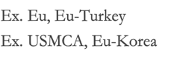  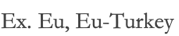  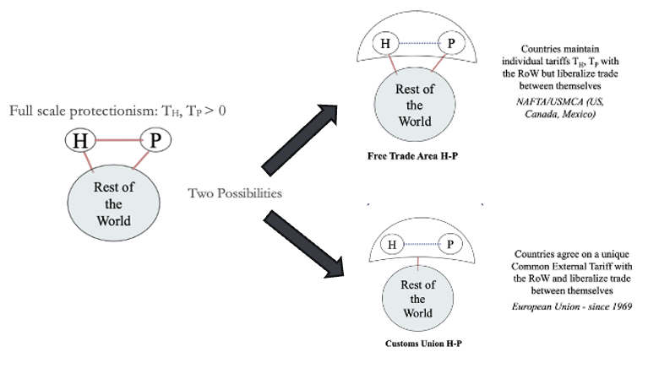  *In the last years there was a boom in FTAs, and now more than 1/3 of global trade takes place within RIAs)  Are Custom Unions better?  Strictly economical pov: FTA more efficient. But you have to consider how CU affects transaction costs:  -- CUs allow countries to have higher bargaining pow --> ‘small’ countries act as ‘big’ ones = credible threat of rising t  -- No need for rules of origin  -- If you have a common market…. with economies of scale it is cost-effective to concentrate production in one specific location belonging to the CU!  + CUs imply high political cost of negotiation  Trade deflection  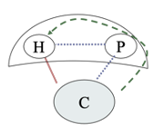  FTA between Home Us (H) and Partner Mex (P), P han no tariff on C, H has tariffs on C  Problem: C can export to P duty free and then re-export to H, hence circumnavigating the tariff (and viceversa).  Solution: Rules of origin to assess the nationality of traded goods. Only goods that have origin (whose value added is mostly created in P*) can freely circulate between H and P  .  *Details vary by product and specify what percentage of a product's value or which specific processes must occur within the region for the good to qualify as originating.

